# Question 01

## Code

clc

clear all

% a

syms x

f=@(x)5*x^4 -3*x^3+4*x^2 +8*x-3;

diff_f=@(x)20*x^3 - 9*x^2 + 8*x + 8;

x=.7;

iter=[];

exect=0.3264;

err=[];

for i=1:3

iter=[iter (x-(f(x)/diff_f(x)))];

x=iter(i);

err= [err abs((exect-x)/x)*100];

end

iter

err

% b

x=0.7;

x1=0.4;

f1=@(x1)5*x1^4 -3*x1^3+4*x1^2 +8*x1-3;

second_err=[];

second_iter=[];

for i=1:3

second_iter=[second_iter x- (f(x)*(x-x1))/(f(x)-f(x1))];

x=second_iter(i);

second_err= [second_err abs((exect-x)/x)*100];

end

second_iter

second_err

## Output

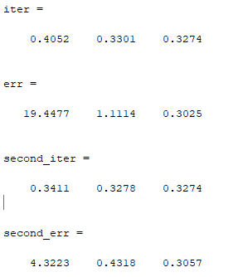

# Question 02

## Code

clc

clear all

xi=0;

xu=2;

f1=@(x1)1.5*x1^4 -3.2*x1^3+2.4*x1^2 +0.8*x1 + 15;

f2=@(x2)1.5*x2^4 -3.2*x2^3+2.4*x2^2 +0.8*x2 + 15;

d=((sqrt(5)- 1)/2)*(2-0)

x1=xi+d;

x2=xu+d;

f1_1=f1(x1)

f2_1=f2(x2)

% second iteration

d=((sqrt(5)- 1)/2)*(d-0)

x1=xi+d;

x2=xu+d;

f1_2=f1(x1)

f2_2=f2(x2)

## Output

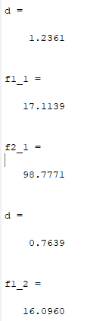

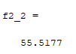

# Question 3

# Code

clc

clear all

A=[1 1 1 0; 2 -2 -5 0; 3 0 1 1; 4 -2 -3 1];

B=[6;13;13;1];

output=inv(A)*B;

x=output(1)

y=output(2)

z=output(3)

w=output(4)

# Output

